AML Detection data review and modelling

Dataset.head()

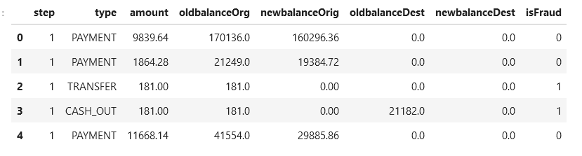

**Model Suggested**

SVM was used to detect if there is fraud based on account and transaction details.

**Model results**

Accuracy about 94%

